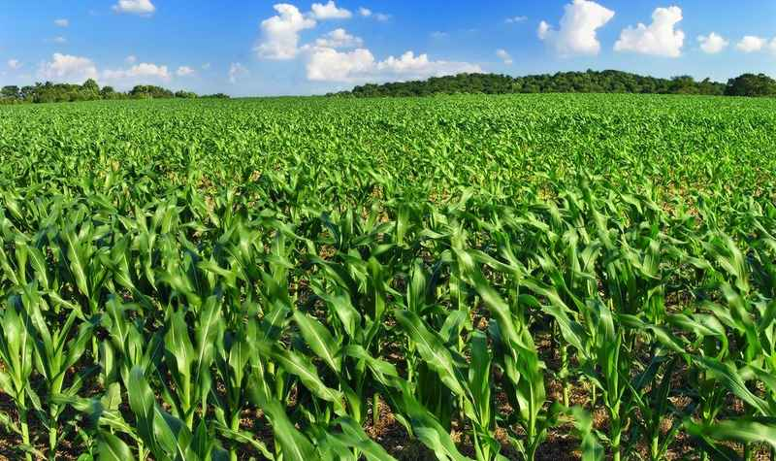

SALL PROJECT

[24-06-2021]

Made by: Arif Ulu, Cedric van Dam and Aya Yacoubi

Table of
contents

Schools as Living Labs _____________________________ 03
Issue __________________________________________ 04
Deliverable 1 ____________________________________ 05
Deliverable 2 & 3 _________________________________ 06
Conclusion? _____________________________________ 07
Sources _________________________________________ 08

SALL
SCHOOL AS LIVING
LABS
We are one of the school participating in the SALL project. It is an international project involving schools all over Europe. SALL stands for: School As Living Labs. The company SALL anchors their approach in existing methodologies for open schools. The project will create a living lab-based methodology and develop training and support materials. The methodology and materials will be tested and evaluated in 42 pilot school communities in 10 countries.

SALL website: https://www.schoolsaslivinglabs.eu/












Issue

You've probably heard about it before: the nitrogen problem. Farmers with tractors protesting against the nitrogen law. It is quite difficult to solve this problem. Nitrogen (N2) is one of the substances that enhances the greenhouse effect. Simply explained: the more nitrogen in the air, the stronger the greenhouse effect becomes. So the problem statement of our project is: how can we reduce nitrogen emissions from farmers?

The problem is that nitrogen is mostly produced by farmers. So they want to reduce that there. Farmers then have to limit themselves in livestock, but with little livestock you do not earn as much as a farmer. We must therefore find a solution for reducing nitrogen among farmers, without causing disadvantages for them.

At the end no one of them reponded back at our emails. We didn’t find a stakeholder, but that didn’t mean that we had to give up. We still did part of the project without a stakeholder.
We looked for stakeholders. These stakeholders must be involved in the problem statement. Search their website, their phone number and preferably the email address. Then we have contacted the all the take holders one by one.

Deliverable 1

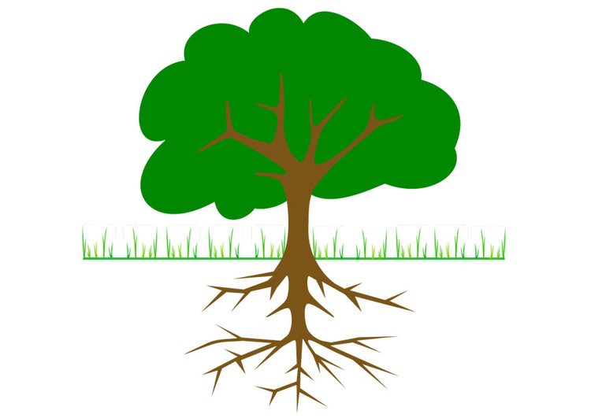
We made an infographic/drawing with the information that we as a group already know about the subject and some information of internet. The infographic should contain the problem statement, its causes and its consequences. We have also brainstormed for possible solutions.

Deliverable 2 & 3
consequences
Causes
Planting legumes around crops

Less protein in animal food

Ammonia ends up in the air

Minerals in the soil reduce
Monoculture
Mixing crops/mixed cultivation

Oplossingen
solutions
Oplossingen
Part of the manure evaporates as ammonia (NH₃)
Farmers fertilize their land


But we also learned more about the problem of the project self. We knew a bit of the nitrogen problem, but now we know how it’s cause by farmers.
We learned that contacting and get a stakeholder is very hard, because if it’s not intersting enough they ingnore you. Writing a proper e-mail is difficult. And also a problem was time. In the beginnen of the project everthing went slow (we had also an other project at the time this one started) and when the last lesson where there we stressed to much to get things done on time.
Conclusion?
Sources

- SALL. (z.d.). School as Living Labs. Consulted on 24 june 2021, from https://www.schoolsaslivinglabs.eu/
- Scribber. (z.d.). Scribber. Consulted on 24 june 2021, from https://www.scribbr.nl/scriptie-structuur/plan-van-aanpak/
- Calandlyceum technasium. (z.d.). Denknasium. Consulted on 24 june 2021, from https://sites.google.com/site/calandlyceumtechnasium/
- Flipsnack. (z.d.). Flipsnack. Consulted on 24 june 2021, from https://www.flipsnack.com/nl/templates/table-of-contents
- Groupwebsite, team 3. (z.d.). SALL-project. Consulted on 24 june 2021, from https://sall-project.cms.webnode.nl/
- ’t Boerderij Paradijs. (z.d.). ’t Boerderij Paradijs. Consulted on 24 june 2021, from https://boerderijparadijs.nl/
- Stikstof uitstoot. (z.d.). Consulted on 24 june 2021, from https://www.kvk.nl/advies-en-informatie/innovatie/duurzaam-ondernemen/stikstofuitstoot-nederland-hoe-zit-het/

